1. **Original Data Gathering:**

Simple search for ‘zip code square miles’ in Google.

Found Government Census information @ https://factfinder.census.gov/faces/tableservices/jsf/pages/productview.xhtml?src=bkmk

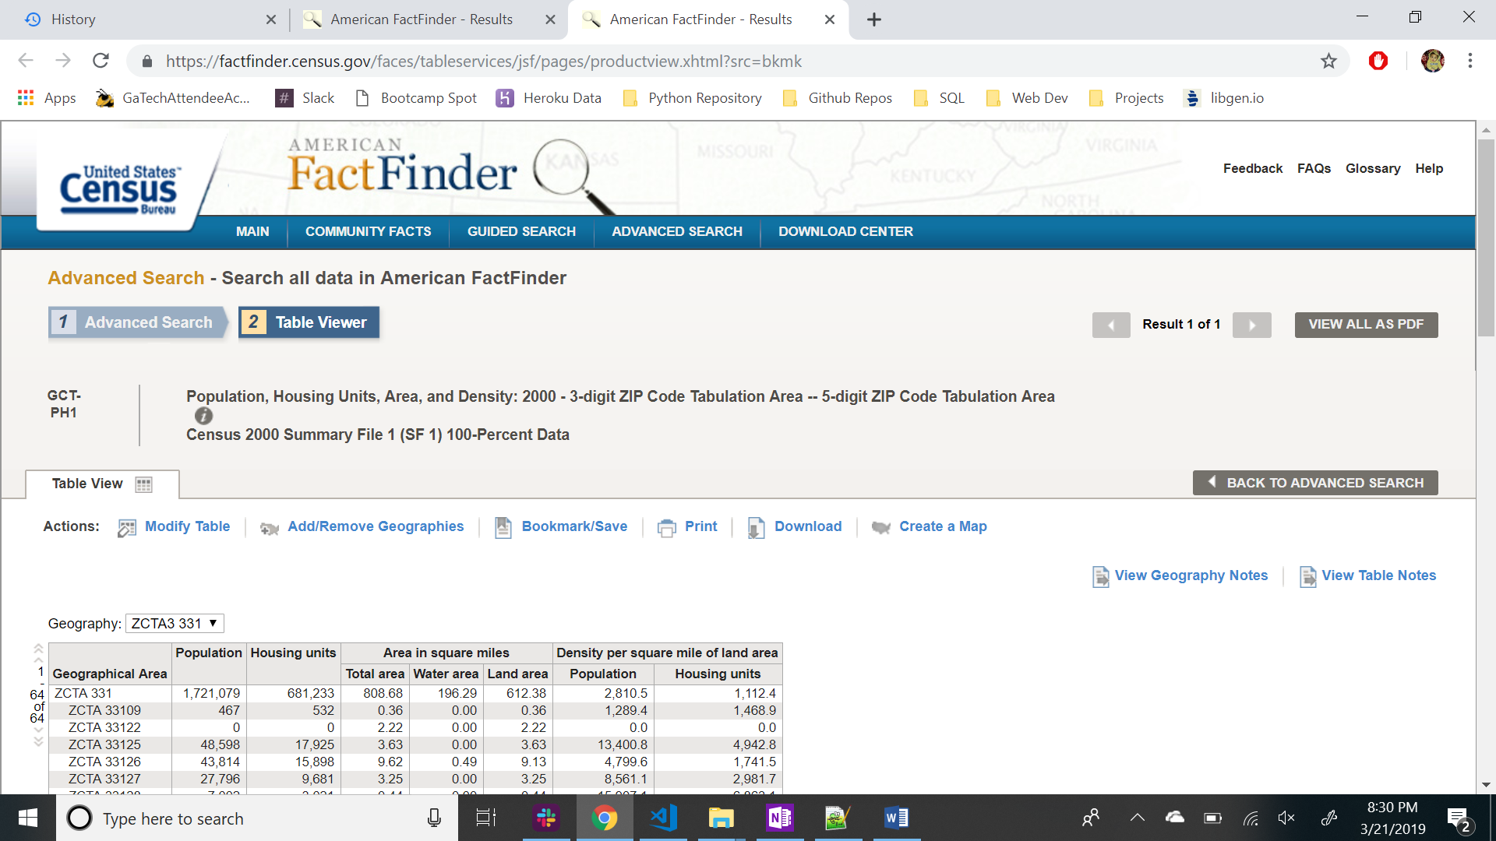

The areas of Population, Housing Units are pre-populated in table format. The objective, now, is to narrow down the data to specific California zip codes. We can use the Fault-line zip codes that we pre-identified, but the zip code filter under the ‘Add/Remove Geographies’ was having issues. The 3-digit zip code was working, so I searched Wikipedia for California’s information:

Wikipedia Search: <https://en.wikipedia.org/wiki/List_of_ZIP_Code_prefixe>

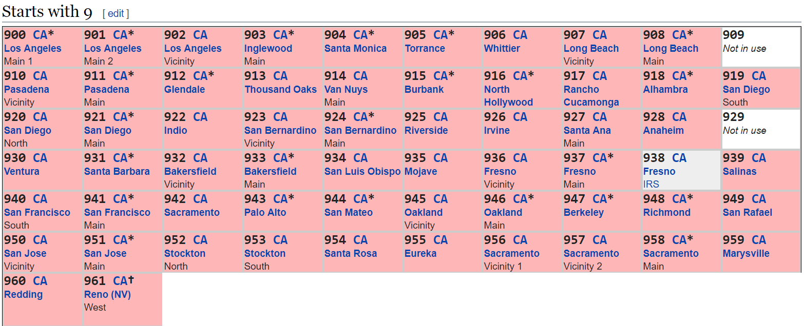

Back to Census data site, I typed the California 3-Digit Zip Codes into the filter: 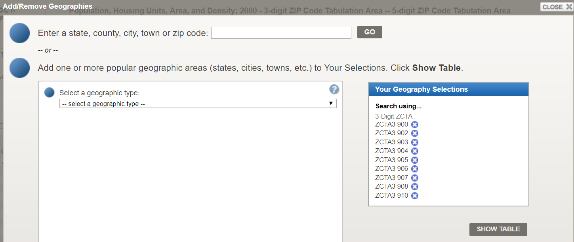

* Click ‘Show Table’

Then ‘download’ the data using the Download button. ‘Use the data’ downloads the data as a csv file.

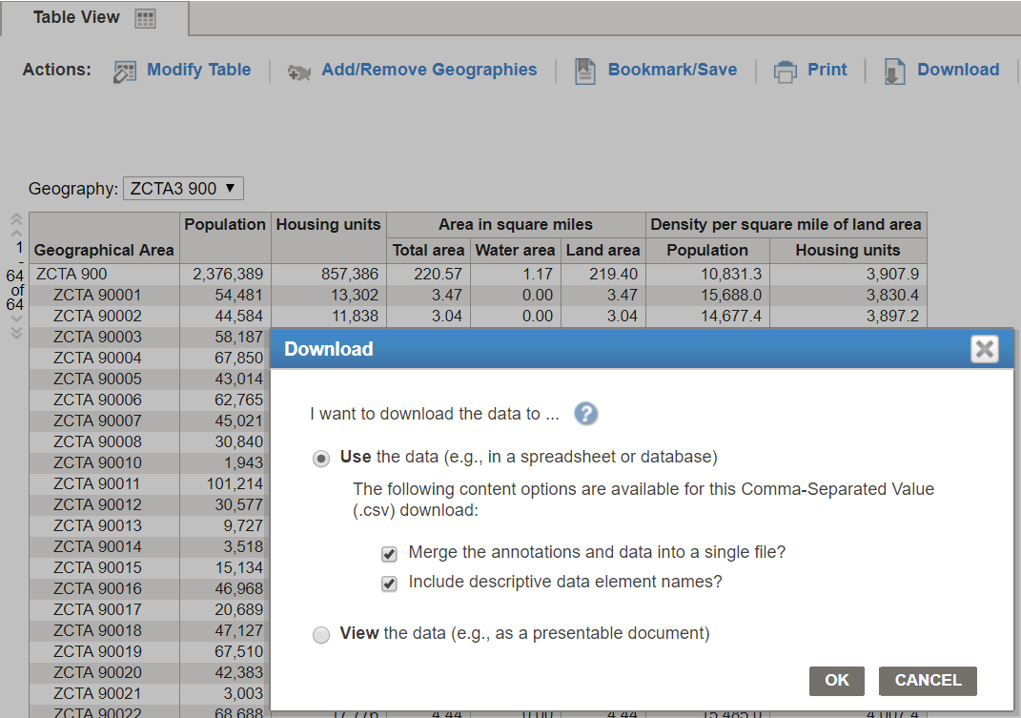

Additional Details on serach attributes from Census site: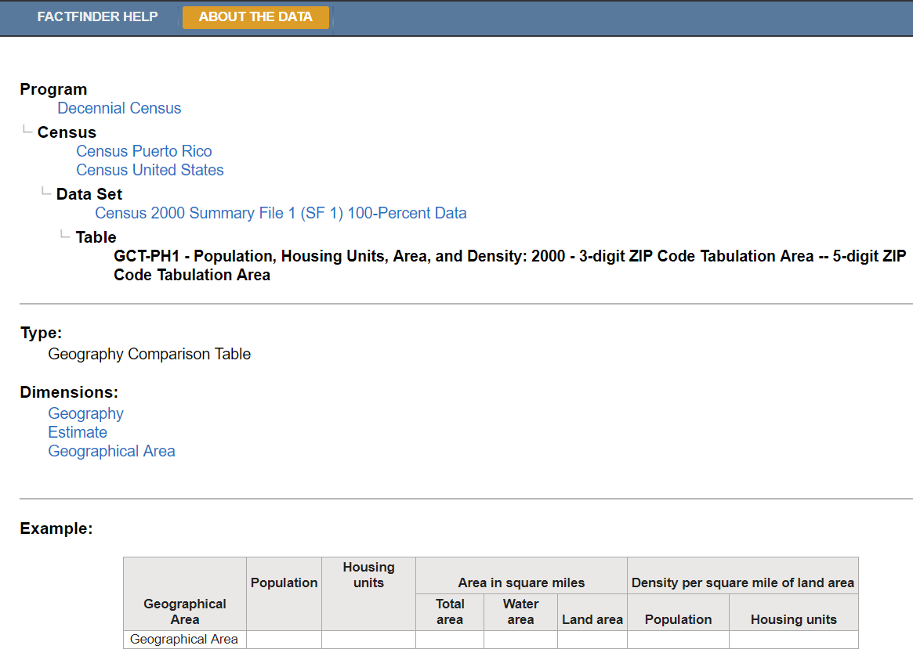

1. **Programmatic Approach.**

Use the the following link as a template.

<https://factfinder.census.gov/bkmk/table/1.0/en/DEC/00_SF1/GCTPH1.ZI09/8500000US900|8500000US902|8500000US903|8500000US904|8500000US905|8500000US906|8500000US907|8500000US908|8500000US910|8500000US911|8500000US912|8500000US913|8500000US914|8500000US915|8500000US916|8500000US917|8500000US918|8500000US919|8500000US920|8500000US921|8500000US922|8500000US923|8500000US924|8500000US925|8500000US926|8500000US927|8500000US928|8500000US930|8500000US931|8500000US932|8500000US933|8500000US934|8500000US935|8500000US936|8500000US937|8500000US939|8500000US940|8500000US941|8500000US943|8500000US944|8500000US945|8500000US946|8500000US947|8500000US948|8500000US949|8500000US950|8500000US951|8500000US952|8500000US953|8500000US954|8500000US955|8500000US956|8500000US957|8500000US958|8500000US959|8500000US960|8500000US961|8500000US967?slice=GEO~8500000US902>

Using an iterator, concatentate the required 3-Digit zip codes to ‘8500000US’ and add a ‘| ‘ and the prefix url.